Step1:Log in to Huawei Cloud ECS and configure the basic environment
- Log in to Huawei Cloud ECS and configure the basic environment
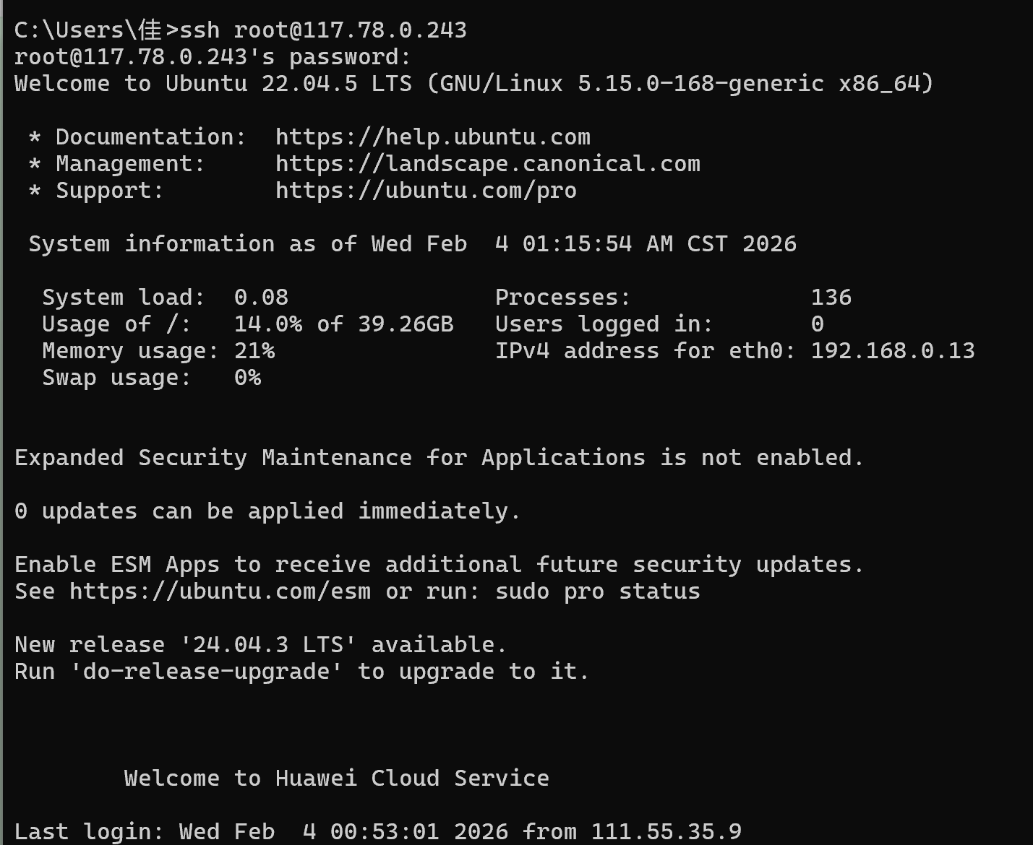
- Download and install Nebula
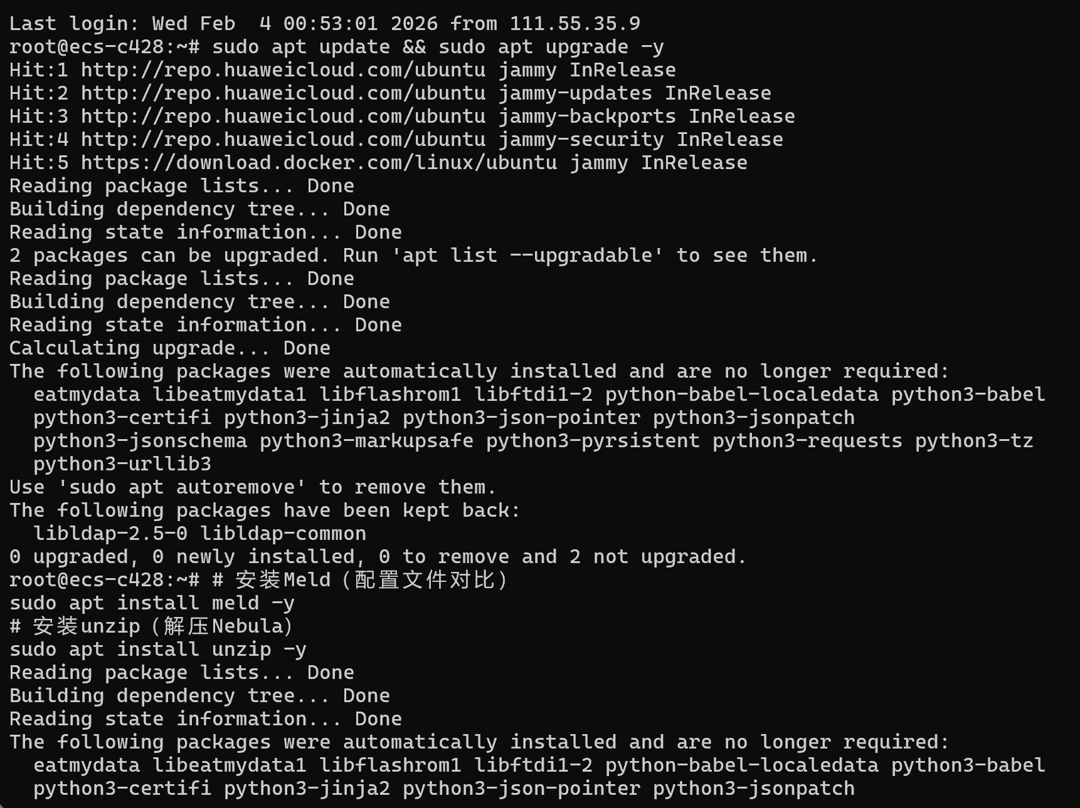
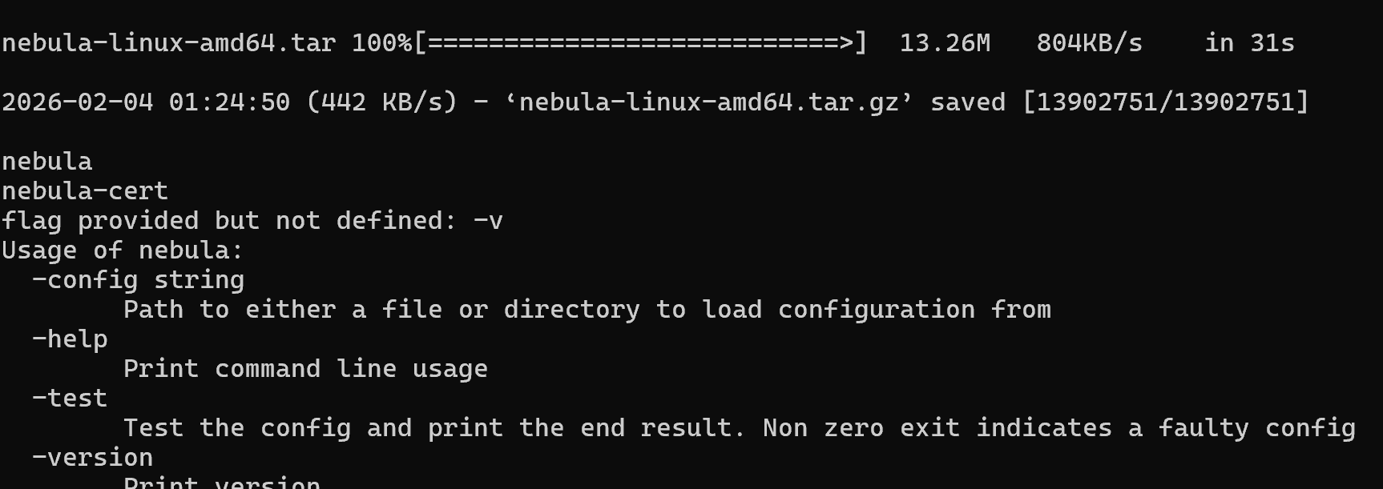
3. Generate Nebula encryption certificates (CA and node certificates)
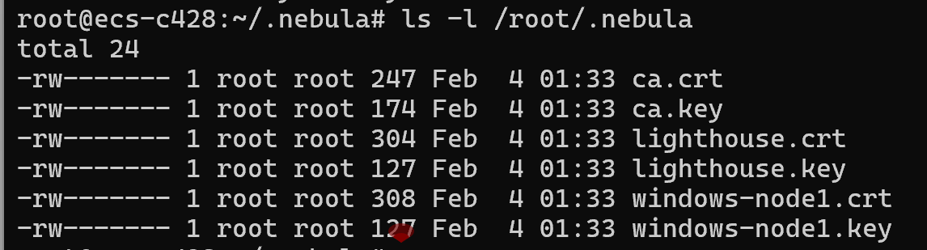
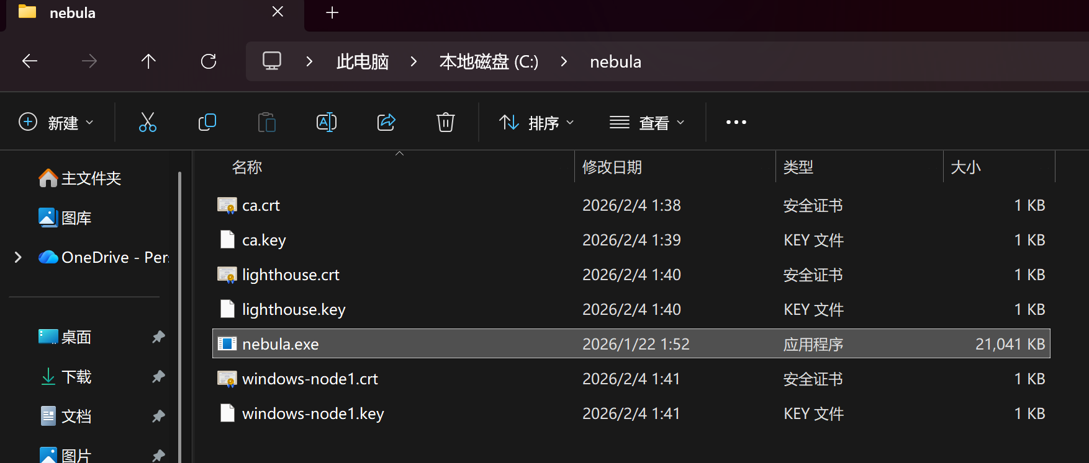
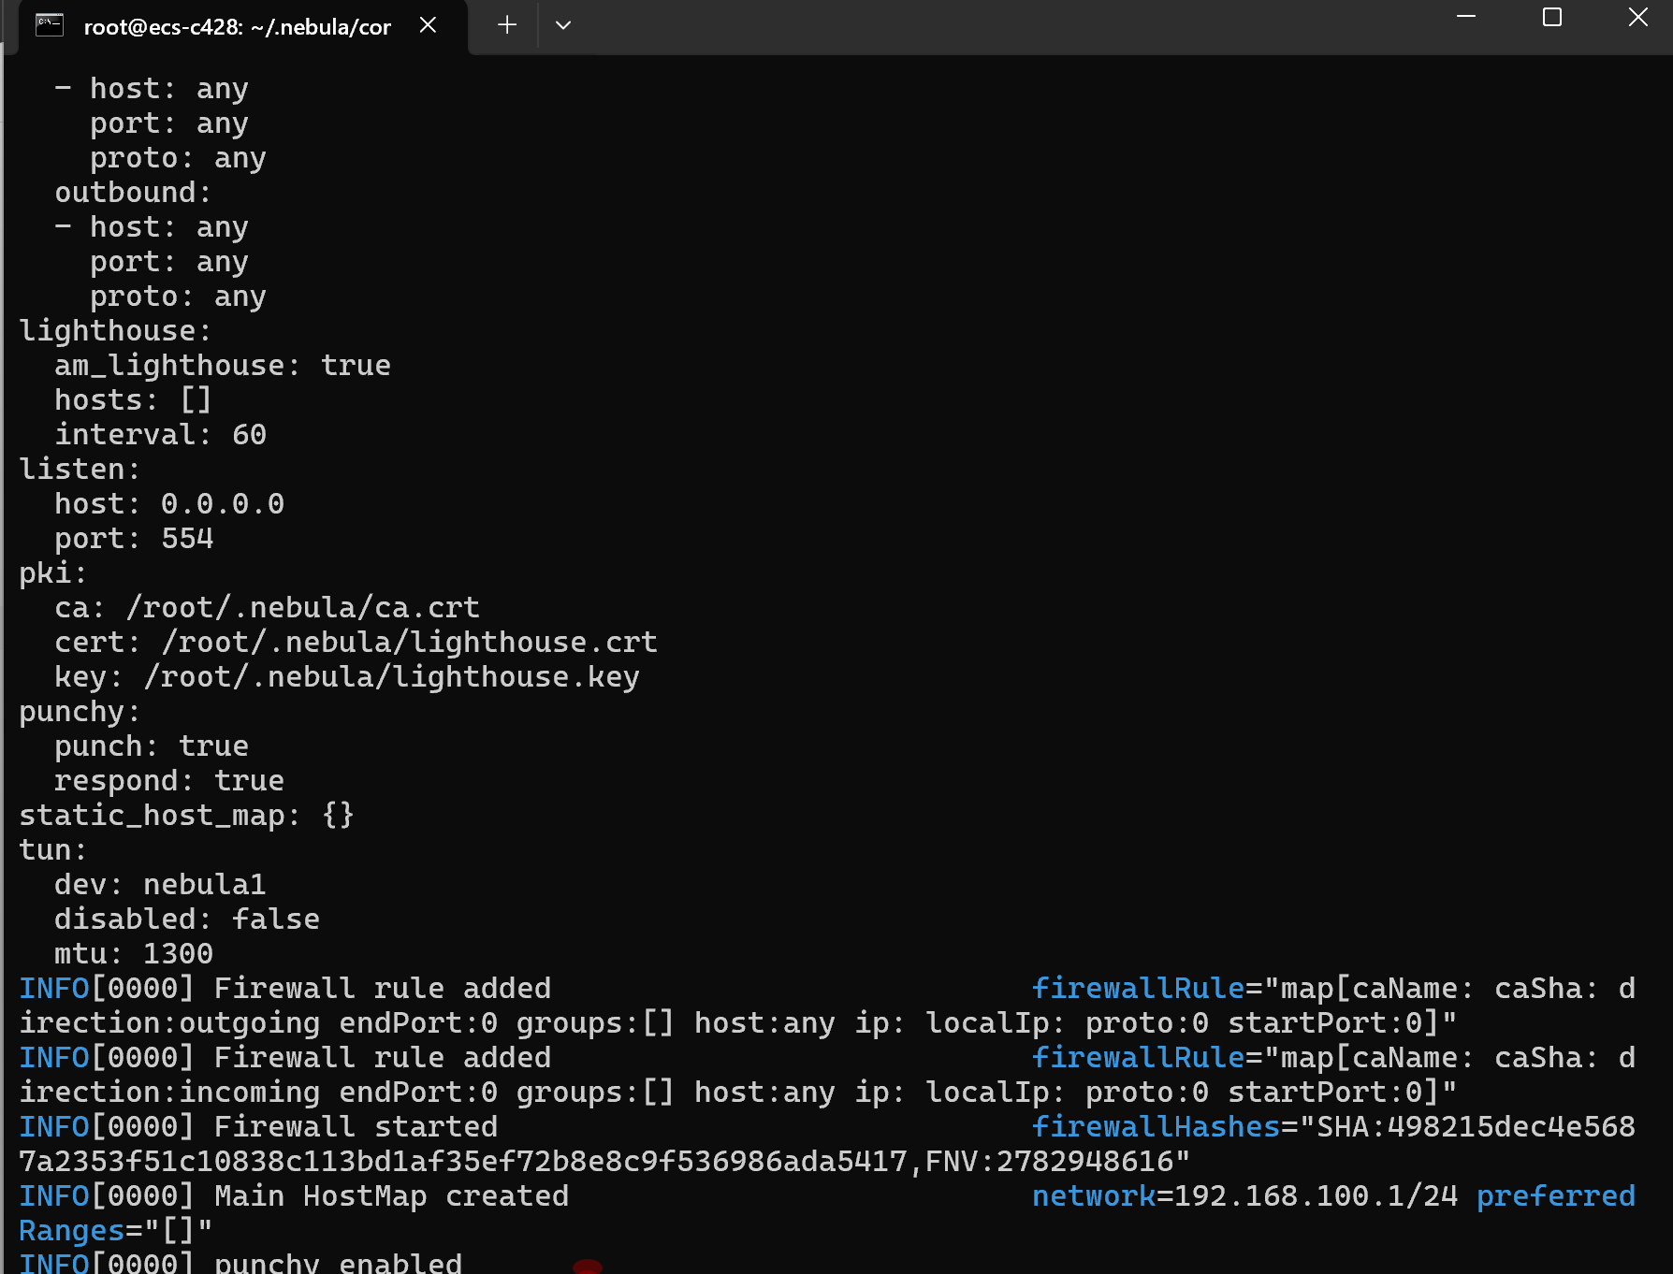
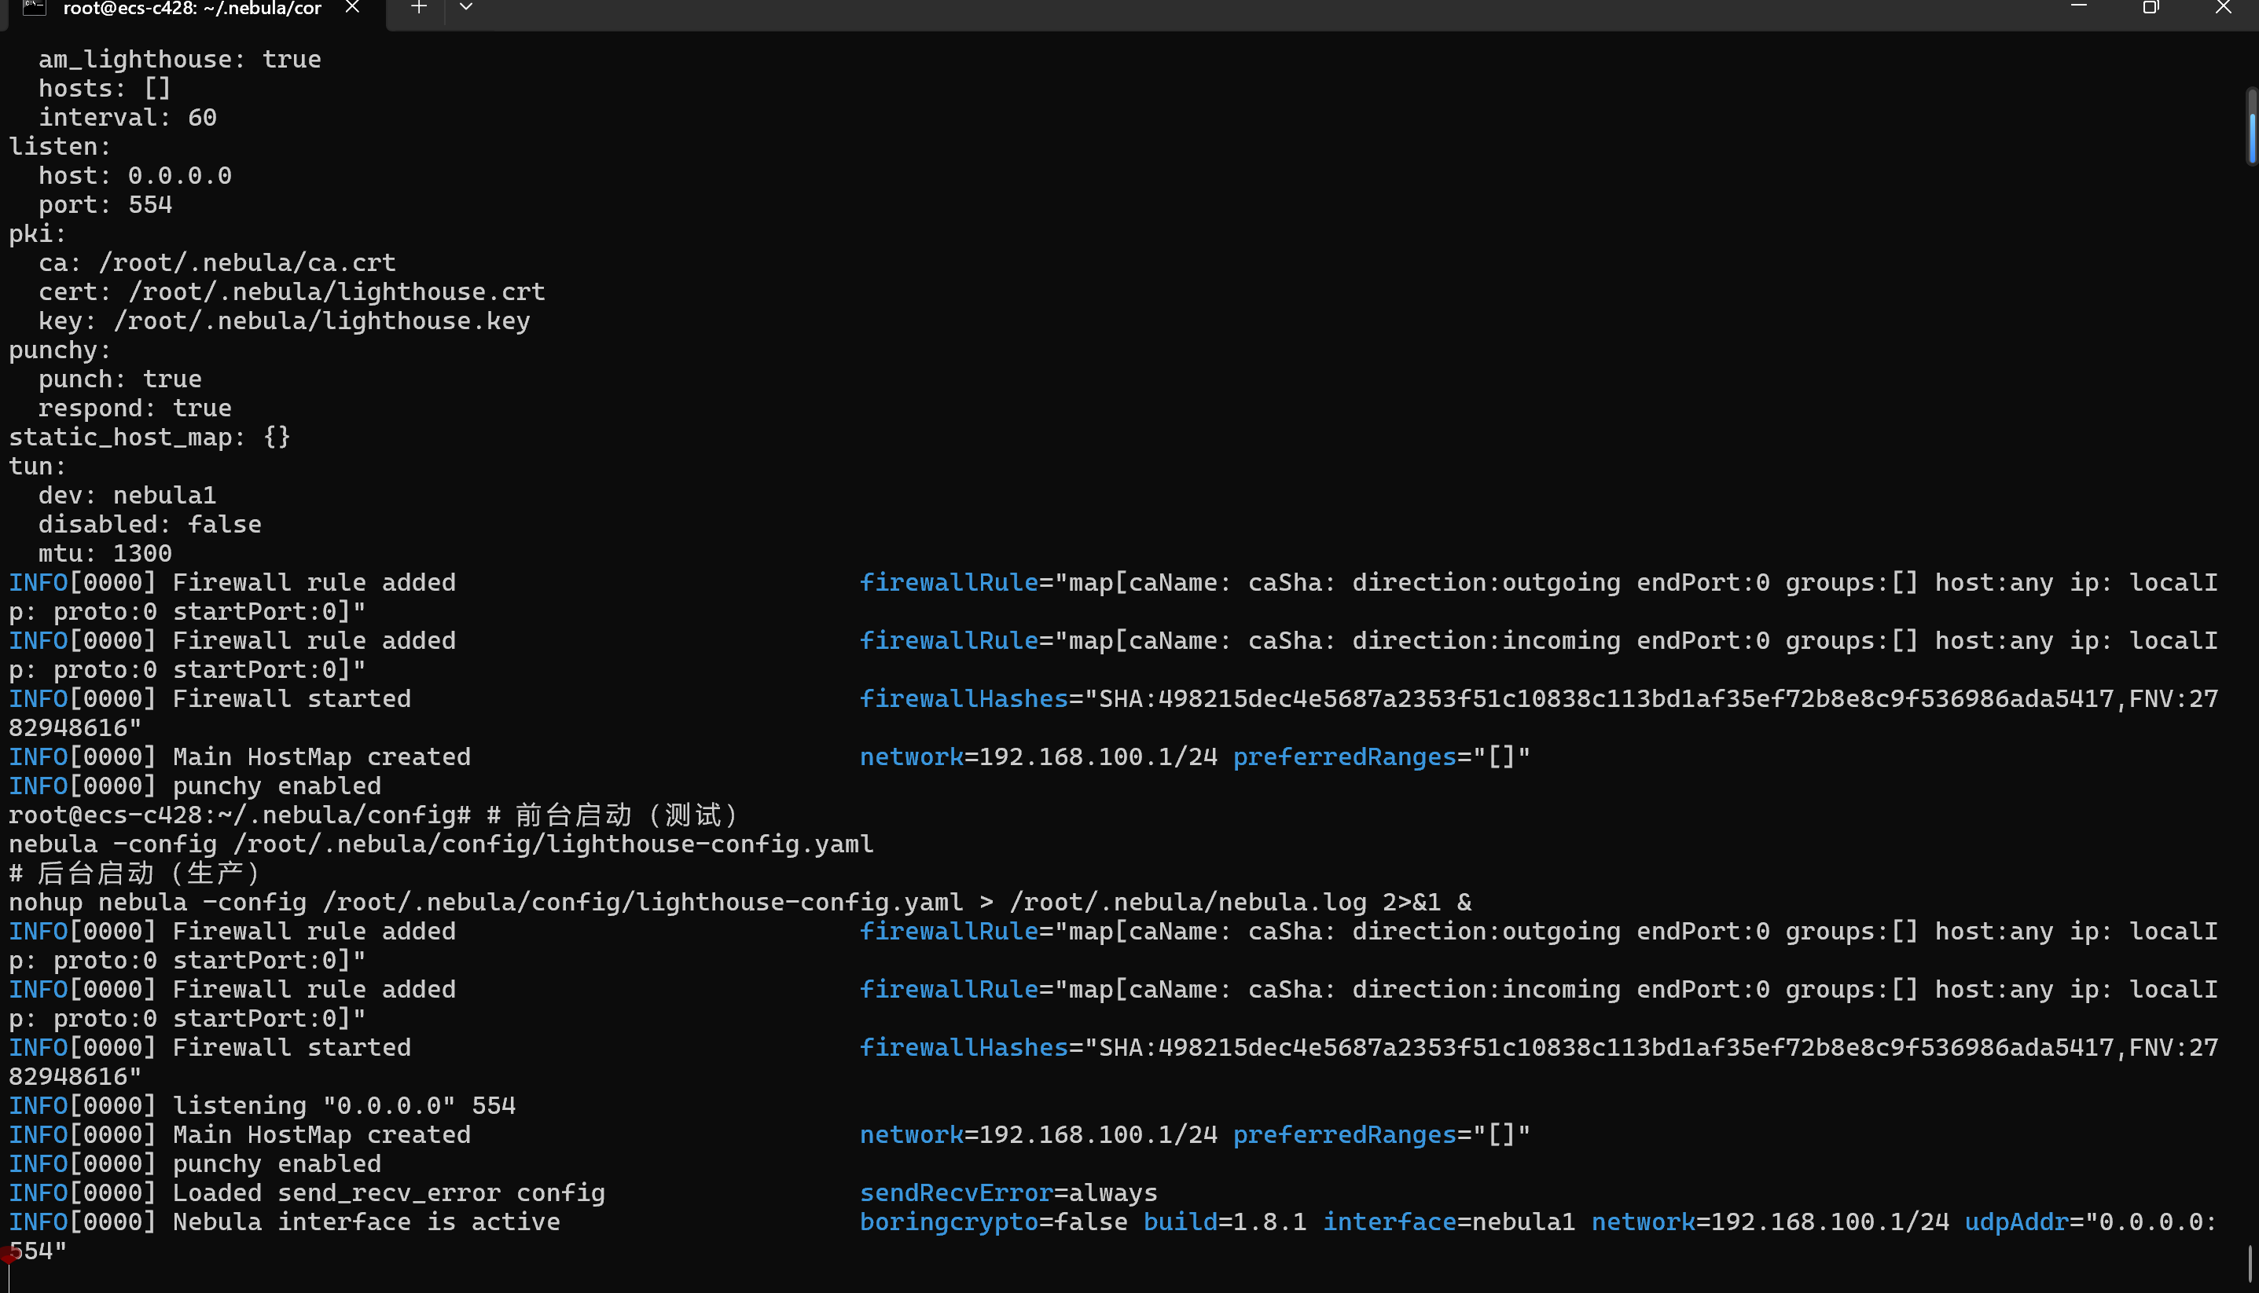

Step2:Configure the Lighthouse node's config.yaml
- Create the configuration file directory
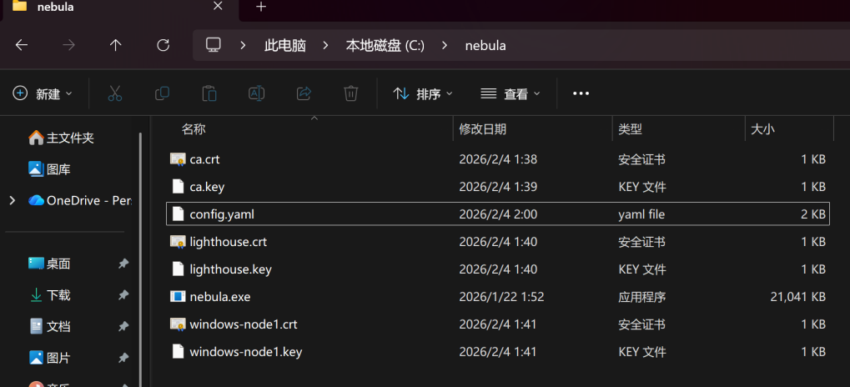
- Write the Lighthouse configuration file
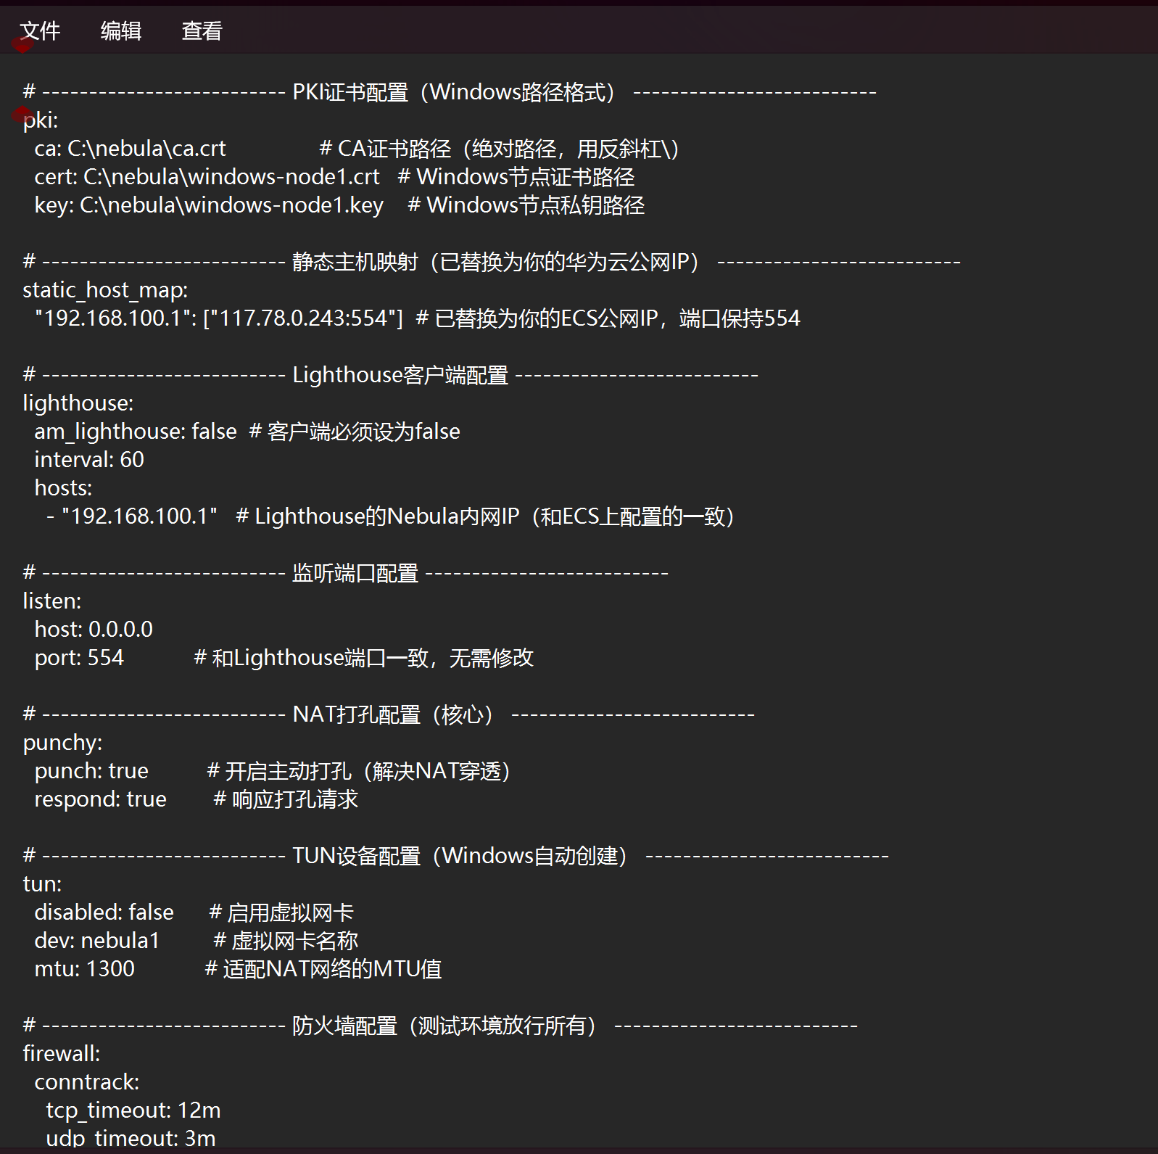

- Start the Lighthouse node
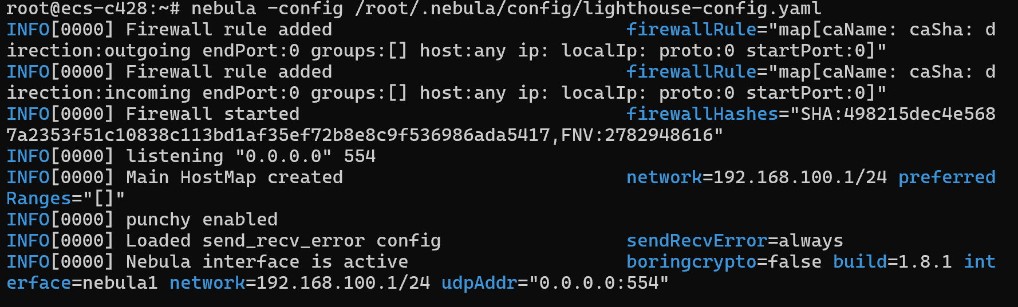
step 3: Configure the Windows node (after NAT)
- Prepare the Windows environment
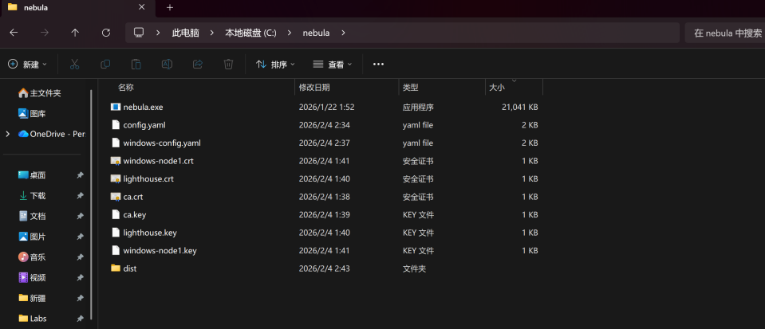
- Write the Windows node configuration file
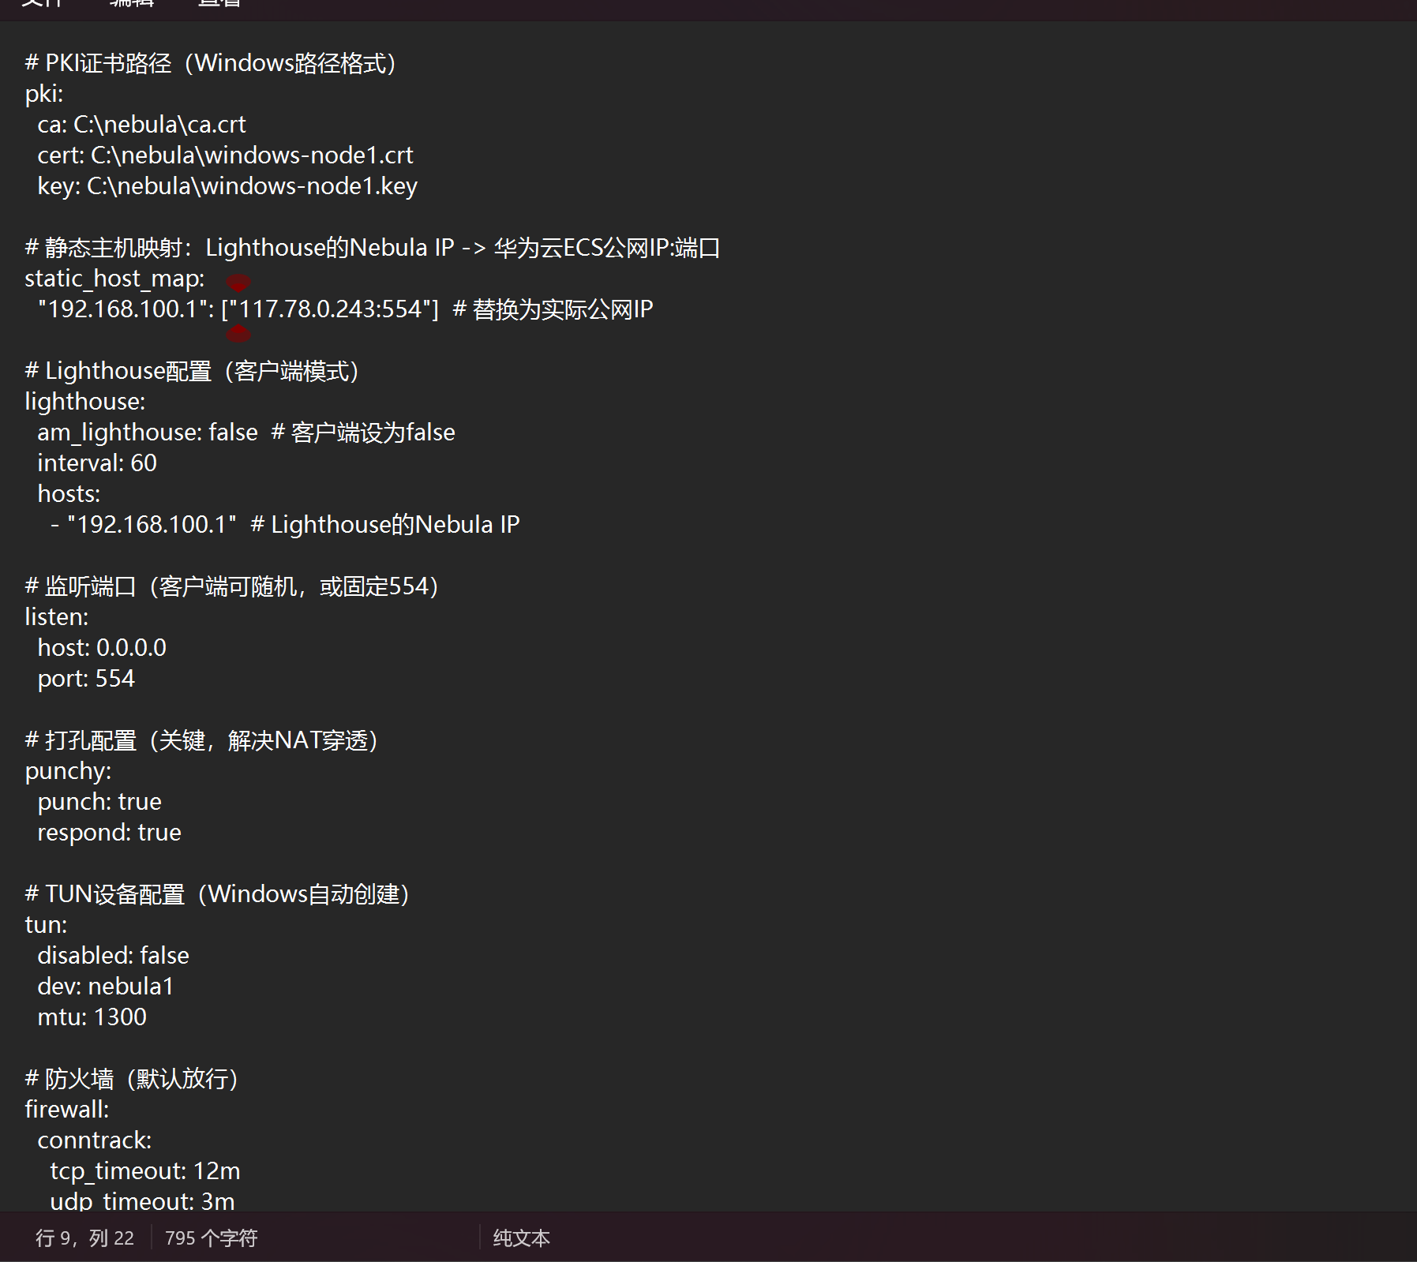
step 4: test ping 192.168.100.2
